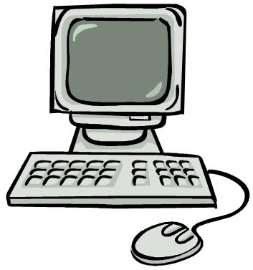
Ms. Goruk
GPMS Computer Graphics and Animations
2014- 2015

Course Description
The 21st century has radically changed how technology is used in our every day lives over the past 20 years. Students are being exposed and encouraged to use new text, video, audio and multi-media communications everyday. In this class students will explore and create effective projects through the use of computer technology and software.

Course Objectives
- Utilize computer programs to improve communication in the 21st century
- Utilize imagery and visual appearance to enhance communication
- Introduce animation forms to enrich digital projects
- Allow student exploratory to enhance knowledge, competency and ease of use in computer communication

Course Assessment
Students have diverse abilities and varied exposure to technology. Students will be assessed on the completion of assignments to the best of their ability, with emphasis being placed on exploring and expanding their current level of knowledge.

Grades will be determined on the ability of a student to demonstrate competency, creativity and innovation. Assignments are mostly completed independently with the exception of assignments closer to the end of the course. Students may choose to demonstrate their abilities further on any given assignment, which may require additional time to complete the assignment. Grades on particular assignments may be affected if students are not utilizing time given. Assignment assessment will focus on effort, creativity, innovation, pace and individual assignment components.
Assignments- 100%

- Selected assignments will be graded through a collaborative assessment between student and teacher
Computer Lab Expectations
- Operate equipment properly and take care of all components (monitor, mouse, keyboard, etc.)
- No food or drinks near computers.
- Report any problems immediately.
- Print only with permission.
- Only visit approved Internet sites and only when you have permission to do so.
- Do not download anything unless told to do so.
- Log off and push chairs in when leaving.

Internet Safety

- Do no give out any personal information online. This includes name, address, e-mail, location of my school, and telephone numbers.
- Do not send your picture to strangers our post publicly online
- When using the Internet, use a pretend name or nickname that doesn’t reveal anything about me.
- When creating a password, make one up that is hard to guess but easy to remember. Do not give out passwords.
- Do not respond to any message that makes you uncomfortable. Show an adult right away.
- Do not open e-mail, files, links, pictures or games from people that you don’t know or trust.
- Do not post or send insulting or rude messages or threats to anyone online.
- Do not believe everything you read on the Internet. Confirm online sources with an adult.
- If you come across something uncomfortable or unsettling show the teacher right away.

